Submitted by – Arsum Javaid 26271006

SQL PRACTICE SET – RETAIL EVENTS DATASET
20 QUESTIONS | EASY → MEDIUM → HARD

DATASET OVERVIEW
================

This practice set uses the retail_events_db database.

Main tables:

1. dim_campaigns
- campaign_id
- campaign_name
- start_date
- end_date

2. dim_products
- product_code
- product_name
- category

3. dim_stores
- store_id
- city

4. fact_events
- event_id
- store_id
- campaign_id
- product_code
- base_price
- promo_type
- quantity_sold(before_promo)
- quantity_sold(after_promo)

The fact_events table stores product-level promotional event information.
Use the dimension tables to obtain campaign, product and store details.

IMPORTANT:
- Use MySQL syntax.
- Column names containing parentheses may need backticks.
Example:
`quantity_sold(before_promo)`
`quantity_sold(after_promo)`
- Do not modify the data.
- Write a separate SQL query for each question.
- Questions are arranged from easy to hard.
- Focus especially on JOINs, GROUP BY, HAVING, CASE, CTEs and window functions.

============================================================
EASY QUESTIONS
============================================================

Q1. Basic Filtering – High-Value Products
Find all event records where the base_price is greater than 1,000.

Display:
- event_id
- store_id
- product_code
- base_price
- promo_type

Concepts:
SELECT, WHERE, comparison operators.

Answer: select event_id, store_id, product_code, base_price, promo_type
from fact_events
where base_price > 1000;

Screenshot: 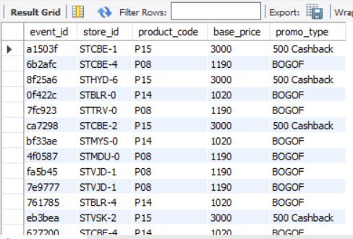

------------------------------------------------------------

Q2. Sorting Promotional Events
Display all events where quantity sold after the promotion was greater than 100.

Display:
- event_id
- product_code
- promo_type
- quantity_sold(before_promo)
- quantity_sold(after_promo)

Sort by quantity_sold(after_promo) in descending order.

Concepts:
WHERE, ORDER BY, DESC.

Answer : select event_id, product_code, promo_type, `quantity_sold(before_promo)`, `quantity_sold(after_promo)`
from fact_events
where `quantity_sold(after_promo)` > 100
order by `quantity_sold(after_promo)` desc;

screenshot of output
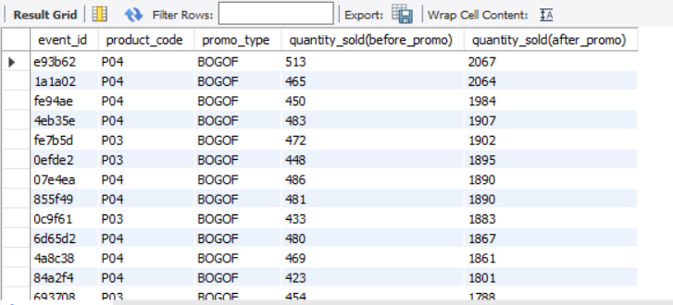
------------------------------------------------------------

Q3. DISTINCT Promotion Types
Find all unique promotion types used in the dataset.

Display only the unique promo_type values.

Concepts:
DISTINCT.

Answer: select distinct promo_type
from fact_events;

screenshot
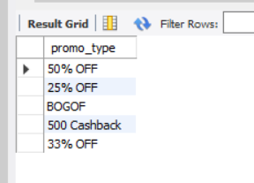

------------------------------------------------------------

Q4. Basic Aggregation
Calculate the following for the complete fact_events table:

- Total number of events
- Total quantity sold before promotion
- Total quantity sold after promotion
- Average base price
- Maximum base price
- Minimum base price

Return all metrics in one row.

Concepts:
COUNT, SUM, AVG, MAX, MIN.

Answer: select count(event_id) as `total number of events`, sum(`quantity_sold(before_promo)`) as `Total Quantity Sold Before Promotion`,
sum(`quantity_sold(after_promo)`) as `Total Quantity Sold After Promotion`, avg(base_price) as `Average Base Price`, max(base_price) as `Maximum Base Price`, min(base_price) as `Minimum Base Price`
from fact_events;

screenshot
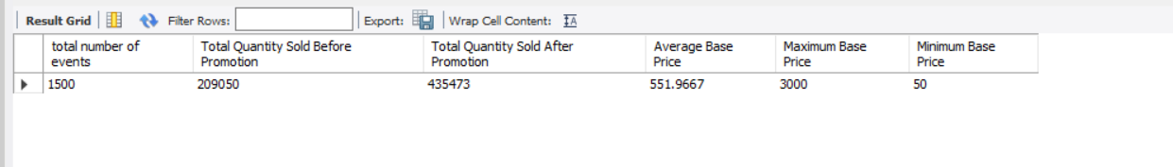

============================================================
MEDIUM QUESTIONS
============================================================

Q5. Sales Volume by Promotion Type
For each promo_type, calculate:

- Number of events
- Total quantity sold before promotion
- Total quantity sold after promotion

Sort by total quantity sold after promotion in descending order.

Concepts:
GROUP BY, COUNT, SUM, ORDER BY.

Answer:
select promo_type, count(event_id) as `Number of Events`, sum(`quantity_sold(before_promo)`) as `Total Quantity Sold Before Promotion`,
sum(`quantity_sold(after_promo)`) as `Total Quantity Sold After Promotion`
from fact_events
group by promo_type
order by `quantity_sold(after_promo)` desc;

screenshot
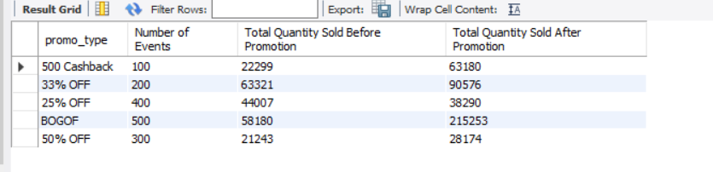
------------------------------------------------------------

Q6. Promotion Uplift
For every promotion type, calculate:

- Total quantity before promotion
- Total quantity after promotion
- Quantity increase/decrease

Use:

Quantity Change = After Promo Quantity - Before Promo Quantity

Display:
- promo_type
- total_before
- total_after
- quantity_change

Sort by quantity_change descending.

Concepts:
GROUP BY, SUM, arithmetic calculations, aliases.

Answer: select promo_type, `quantity_sold(before_promo)` as `Total Quantity Before Promotion`,
`quantity_sold(after_promo)` as `Total Quantity After Promotion`,
(`quantity_sold(after_promo)` - `quantity_sold(before_promo)`) as `Quantity Increase/Decrease`
from fact_events
group by promo_type
order by (`quantity_sold(after_promo)` - `quantity_sold(before_promo)`) desc;

screenshot

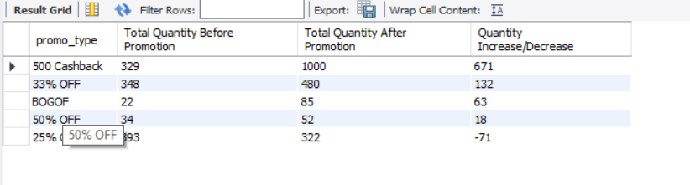

------------------------------------------------------------

Q7. Product Performance
Using fact_events and dim_products, calculate total quantity sold after promotion for every product.

Display:
- product_code
- product_name
- category
- total quantity after promotion

Sort by total quantity after promotion descending.

Concepts:
INNER JOIN, GROUP BY, SUM, ORDER BY.

Answer: select p.product_code, p.product_name, p.category, sum(e.`quantity_sold(after_promo)`) as `Total Quantity After Promo`
from fact_events as e
join dim_products as p
on e.product_code = p.product_code
group by p.product_code, p.product_name, p.category
order by sum(e.`quantity_sold(after_promo)`) desc;
screenshot

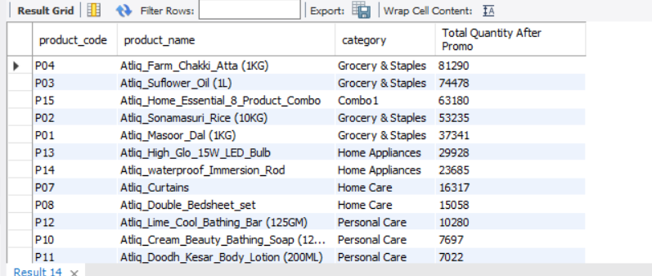
------------------------------------------------------------

Q8. Category-Level Performance
Using fact_events and dim_products, calculate for every product category:

- Number of events
- Total quantity before promotion
- Total quantity after promotion
- Quantity change

Sort categories by total quantity after promotion descending.

Concepts:
JOIN, GROUP BY, SUM, COUNT, arithmetic calculations.

Answer: select category, count(event_id) as `Number of Events`, sum(`quantity_sold(before_promo)`) as `Total Quantity Before Promotion`,
sum(`quantity_sold(after_promo)`) as `Total Quantity After Promotion`, (`quantity_sold(after_promo)` - `quantity_sold(before_promo)`) as `Quantity Change`
from fact_events as e
join dim_products as p
on e.product_code = p.product_code
group by category
order by `quantity_sold(after_promo)` desc;
screenshot
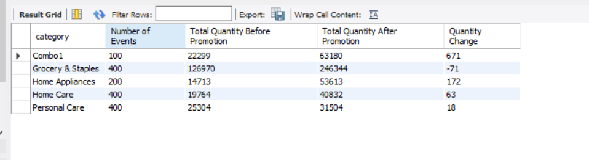

------------------------------------------------------------

Q9. Store Performance
Using fact_events and dim_stores, calculate for every city:

- Number of promotional events
- Total quantity before promotion
- Total quantity after promotion

Display:
- city
- event_count
- total_before
- total_after

Sort cities by total_after descending.

Concepts:
JOIN, GROUP BY, aggregation, ORDER BY.

Answer:
select city, count(event_id) as event_count, sum(`quantity_sold(before_promo)`) as `Total Before`, sum(`quantity_sold(after_promo)`) as `Total After`
from fact_events as e
join dim_stores as s
on e.store_id = s.store_id
group by city
order by sum(`quantity_sold(after_promo)`) desc;

screenshot

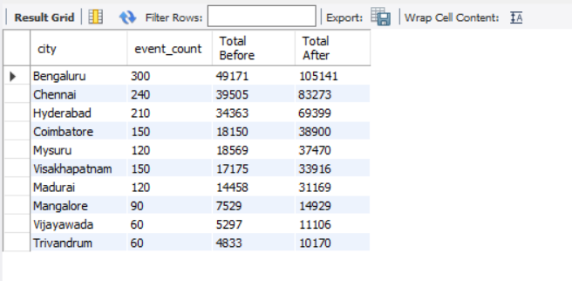

------------------------------------------------------------

Q10. Campaign Performance
Using fact_events and dim_campaigns, calculate for each campaign:

- Campaign name
- Start date
- End date
- Number of events
- Total quantity before promotion
- Total quantity after promotion

Sort by total quantity after promotion descending.

Concepts:
JOIN, GROUP BY, date columns, aggregation.

Answer: select c.campaign_name, c.start_date, c.end_date, count(e.event_id) as `Number of Events`, sum(`quantity_sold(before_promo)`) as `Total qty Before promo`, sum(`quantity_sold(after_promo)`) as `Total Qty After Promo`
from fact_events as e
join dim_campaigns as c
on e.campaign_id = c.campaign_id
group by e.campaign_id, c.campaign_name, c.start_date, c.end_date
order by sum(`quantity_sold(after_promo)`) desc;

screenshot

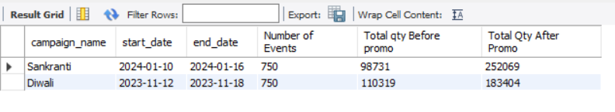
------------------------------------------------------------

Q11. Product Category with HAVING
Find product categories where the total quantity sold after promotion is greater than 1,000.

Display:
- category
- total quantity after promotion
- average base price

Sort by total quantity after promotion descending.

Concepts:
JOIN, GROUP BY, HAVING, AVG, SUM.

Answer:
select p.category, sum(e.`quantity_sold(after_promo)`) as `Total Qty After Promo`, avg(e.base_price) as `Average Base Price`
from fact_events as e
join dim_products as p
on e.product_code = p.product_code
group by p.category
having sum(e.`quantity_sold(after_promo)`) > 1000
order by sum(e.`quantity_sold(after_promo)`) desc;

screenshot

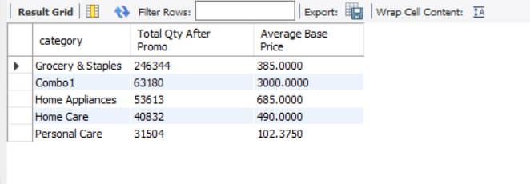
------------------------------------------------------------

Q12. Store + Category Analysis
Using fact_events, dim_stores and dim_products, calculate total quantity sold after promotion for every combination of:

- City
- Product category

Display:
- city
- category
- total quantity after promotion

Sort first by city and then by total quantity descending.

Concepts:
Multiple JOINs, GROUP BY, ORDER BY.

Answer:

select s.city, p.category, sum(e.`quantity_sold(after_promo)`) as `Total Qty After Promo`
from fact_events as e
join dim_stores as s
on e.store_id = s.store_id
join dim_products as p
on e.product_code = p.product_code
group by s.city, p.category
order by s.city asc, sum(e.`quantity_sold(after_promo)`) desc;

screenshot
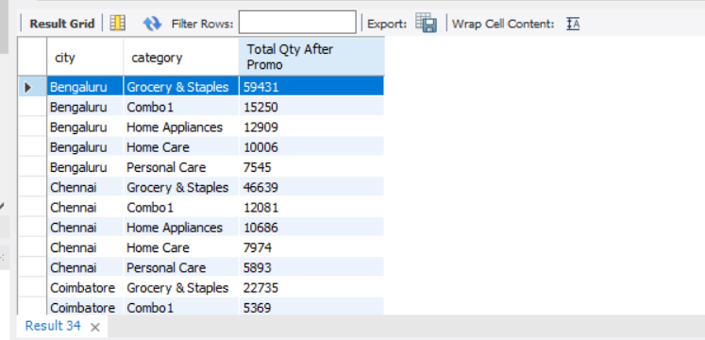

------------------------------------------------------------

Q13. Promotion Effectiveness by Product
For each product, calculate:

- Product name
- Category
- Total quantity before promotion
- Total quantity after promotion
- Quantity change
- Percentage change

Use:

Percentage Change =
((After Promo - Before Promo) / Before Promo) * 100

Handle division by zero appropriately.

Sort by percentage change descending.

Concepts:
JOIN, GROUP BY, arithmetic calculations, NULLIF, percentage calculations.

Answer:
select product_name, category, sum(`quantity_sold(before_promo)`) as `Total qty Before promo`, sum(`quantity_sold(after_promo)`) as `Total Qty After Promo`,
(`quantity_sold(after_promo)` - `quantity_sold(before_promo)`) as `Quantity Change`,
(((`quantity_sold(after_promo)` - `quantity_sold(before_promo)`) * 100) / NULLIF(sum(`quantity_sold(before_promo)`), 0)) as `Percentage Change`
from dim_products as p
join fact_events as e
on p.product_code = e.product_code
group by p.product_code, p.product_name
order by `Percentage Change` desc;

screenshot

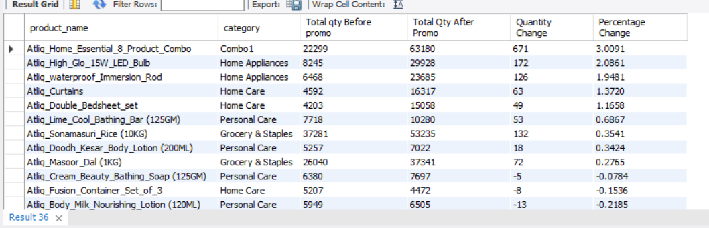

------------------------------------------------------------

Q14. Campaign and Promotion Type Analysis
For each campaign and promo_type combination, calculate:

- Number of events
- Total quantity before promotion
- Total quantity after promotion
- Quantity change

Display:
- campaign_name
- promo_type
- event_count
- total_before
- total_after
- quantity_change

Sort by campaign_name and quantity_change descending.

Concepts:
Multiple GROUP BY columns, JOIN, aggregation, ORDER BY.

Answer:
select c.campaign_name, e.promo_type, count(e.event_id) as `Number of Events`, sum(`quantity_sold(before_promo)`) as `Total qty Before promo`, sum(`quantity_sold(after_promo)`) as `Total Qty After Promo`,
(`quantity_sold(after_promo)` - `quantity_sold(before_promo)`) as `Quantity Change`
from fact_events as e
join dim_campaigns as c
on e.campaign_id = c.campaign_id
group by c.campaign_name, e.promo_type
order by campaign_name asc, `Quantity Change` desc;

screenshot

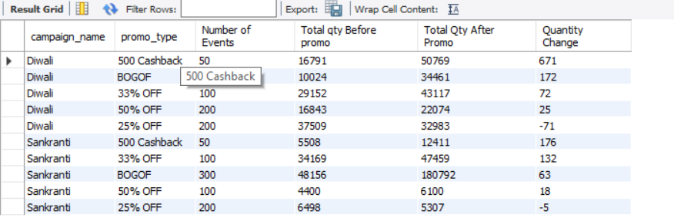

------------------------------------------------------------

Q15. Product Revenue Before and After Promotion
For each product, calculate:

1. Revenue before promotion =
base_price × quantity_sold(before_promo)

2. Revenue after promotion =
base_price × quantity_sold(after_promo)

3. Revenue difference =
Revenue after - Revenue before

Display:
- product_name
- category
- revenue_before
- revenue_after
- revenue_difference

Sort by revenue_difference descending.

Concepts:
JOIN, GROUP BY, SUM, arithmetic calculations, aliases.

Answer:

select p.product_name, p.category, (e.base_price * e.`quantity_sold(before_promo)`) as `revenue_before`,
(e.base_price * e.`quantity_sold(after_promo)`) as `revenue_after`,
((e.base_price * e.`quantity_sold(after_promo)`) - (e.base_price * e.`quantity_sold(before_promo)`)) as `Revenue Difference`
from fact_events as e
join dim_products as p
on e.product_code = p.product_code
group by p.product_code, p.product_name, p.category
order by ((e.base_price * e.`quantity_sold(after_promo)`) - (e.base_price * e.`quantity_sold(before_promo)`)) desc;

screenshot:
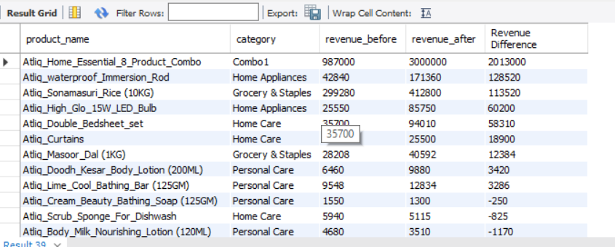

------------------------------------------------------------

Q16. Classify Promotion Performance
For every promotion type, calculate total quantity before and after promotion.

Then classify the promotion using CASE:

- Percentage change >= 50% → "High Impact"
- Percentage change >= 20% → "Medium Impact"
- Percentage change < 20% → "Low Impact"

Display:
- promo_type
- total_before
- total_after
- percentage_change
- performance_category

Sort by percentage_change descending.

Concepts:
GROUP BY, CASE, arithmetic calculations, NULLIF, aliases.

Answer:

select promo_type, sum(`quantity_sold(before_promo)`) as `Total Before`, sum(`quantity_sold(after_promo)`) as `Total After`,
(((`quantity_sold(after_promo)` - `quantity_sold(before_promo)`) * 100) / NULLIF(sum(`quantity_sold(before_promo)`), 0)) as `Percentage Change`
, CASE WHEN (((`quantity_sold(after_promo)` - `quantity_sold(before_promo)`) * 100) / NULLIF((`quantity_sold(before_promo)`), 0)) >= 50 THEN "High Impact"
WHEN (((`quantity_sold(after_promo)` - `quantity_sold(before_promo)`) * 100) / NULLIF(sum(`quantity_sold(before_promo)`), 0)) >= 20 THEN "Medium Impact"
WHEN (((`quantity_sold(after_promo)` - `quantity_sold(before_promo)`) * 100) / NULLIF(sum(`quantity_sold(before_promo)`), 0)) < 20 THEN "Low Impact"
END AS `Performance`
from fact_events
group by promo_type
order by (((`quantity_sold(after_promo)` - `quantity_sold(before_promo)`) * 100) / NULLIF(sum(`quantity_sold(before_promo)`), 0)) desc;

screenshot

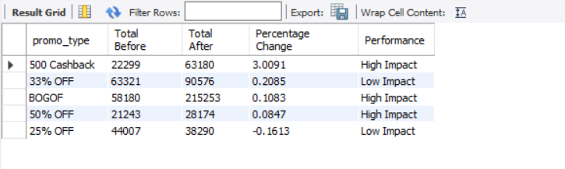

============================================================
HARD QUESTIONS
============================================================

Q17. Top Products Within Each Category
Using a CTE:

1. Calculate total quantity sold after promotion for every product.
2. Rank products within each category based on total quantity sold after promotion.
3. Return only the top 2 products from every category.

Display:
- category
- product_name
- total_quantity_after
- category_rank

Concepts:
CTE, JOIN, GROUP BY, DENSE_RANK/ROW_NUMBER,
PARTITION BY, window functions.

Answer:
with temp as (
select p.category as Category, p.product_name as ProductName, sum(`quantity_sold(after_promo)`) as `Total Qty Sold After Promotion`,
row_number() over (
partition by p.category
order by sum(`quantity_sold(after_promo)`)
) as Category_Rank
from fact_events as e
join dim_products as p
on e.product_code = p.product_code
group by p.product_code
)
select Category, ProductName, `Total Qty Sold After Promotion`, Top_2
from temp
where Category_Rank <=2;

screenshot:

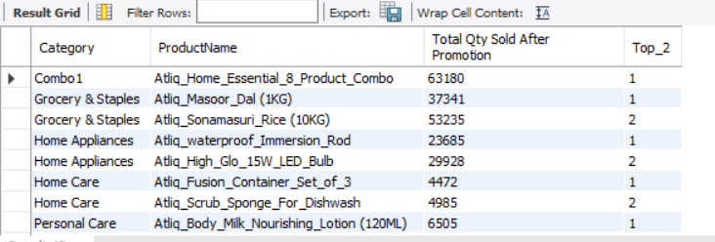
------------------------------------------------------------

Q18. Best-Performing Stores Within Each City
Calculate total quantity sold after promotion for each store.

Join dim_stores to obtain the city.

Then rank stores within each city based on total quantity sold after promotion.

Return the top 2 stores from each city.

Display:
- city
- store_id
- total_quantity_after
- city_rank

Concepts:
JOIN, CTE, GROUP BY, window functions,
PARTITION BY, RANK/DENSE_RANK.

Answer:
with temp as (
select s.city, s.store_id, sum(`quantity_sold(after_promo)`) as `Total Qty Sold After Promotion`,
row_number() over (partition by s.city order by sum(`quantity_sold(after_promo)`) desc) as CityRank
from fact_events as e
join dim_stores as s
on e.store_id = s.store_id
group by s.store_id
)
select *
from temp
where CityRank <=2;

screenshot

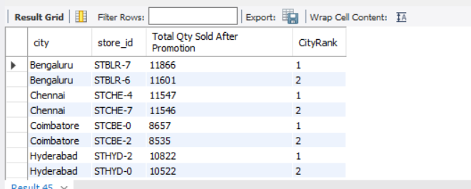

------------------------------------------------------------

Q19. Campaign-Level Product Performance
For every campaign and product:

Calculate:
- Total quantity before promotion
- Total quantity after promotion
- Quantity change
- Percentage change

Then rank products within each campaign based on percentage change.

Return the top 3 products for every campaign.

Display:
- campaign_name
- product_name
- total_before
- total_after
- quantity_change
- percentage_change
- campaign_rank

Concepts:
Multiple JOINs, CTE, GROUP BY, arithmetic calculations,
NULLIF, window functions, PARTITION BY, ranking.

Answer:

with temp as (
select campaign_name as CampaignName, product_name as ProductName,
sum(`quantity_sold(before_promo)`) as `Total Qty Sold Before promo`, sum(`quantity_sold(after_promo)`) as `Total Qty Sold After Promo`,
(sum(`quantity_sold(after_promo)`) - sum(`quantity_sold(before_promo)`)) as `Quantity Change`,
(((sum(`quantity_sold(after_promo)`) - sum(`quantity_sold(before_promo)`)) * 100) / NULLIF(sum(`quantity_sold(before_promo)`), 0)) as `Percentage Change`,
row_number() over (partition by campaign_name order by (((sum(`quantity_sold(after_promo)`) - sum(`quantity_sold(before_promo)`)) * 100) / NULLIF(sum(`quantity_sold(before_promo)`), 0)) desc) as CampaignRank
from fact_events as e
join dim_campaigns as c
on e.campaign_id = c.campaign_id
join dim_products as p
on e.product_code = p.product_code
group by campaign_name, product_name
)

select *
from temp
where CampaignRank <=3;

screenshot:

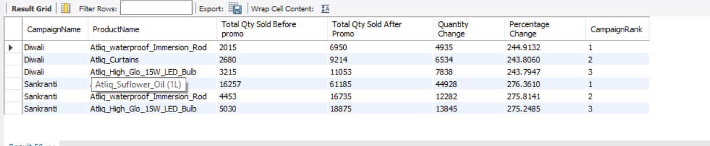

------------------------------------------------------------

Q20. Complete Promotional Performance Analysis
Create a complete analytical report at the product-category level.

For every product, calculate:

- Product name
- Category
- Number of promotional events
- Total quantity before promotion
- Total quantity after promotion
- Quantity change
- Percentage change
- Revenue before promotion
- Revenue after promotion
- Revenue change
- Average base price
- Product rank within its category

Use:

Quantity Change =
Total After - Total Before

Percentage Change =
((Total After - Total Before) / Total Before) * 100

Revenue Before =
SUM(base_price × quantity_before)

Revenue After =
SUM(base_price × quantity_after)

Revenue Change =
Revenue After - Revenue Before

Then:

1. Rank products within each category by Revenue Change.
2. Return only the top 2 products from each category.
3. Use appropriate handling for division by zero.

Concepts:
- Multiple JOINs
- CTEs
- GROUP BY
- COUNT
- SUM
- AVG
- CASE
- NULLIF
- Arithmetic calculations
- Percentage calculations
- Window functions
- PARTITION BY
- DENSE_RANK / ROW_NUMBER
- Filtering ranked results
- Business analysis

Answer:

with temp as (
select product_name, category, count(event_id) as `Number of Promotional Events`,
sum(`quantity_sold(before_promo)`) as `Total Qty Sold Before promo`, sum(`quantity_sold(after_promo)`) as `Total Qty Sold After Promo`,
(sum(`quantity_sold(after_promo)`) - sum(`quantity_sold(before_promo)`)) as `Quantity Change`,
(((sum(`quantity_sold(after_promo)`) - sum(`quantity_sold(before_promo)`)) * 100) / NULLIF(sum(`quantity_sold(before_promo)`), 0)) as `Percentage Change`,
sum(e.base_price * e.`quantity_sold(before_promo)`) as `revenue_before`,
sum(e.base_price * e.`quantity_sold(after_promo)`) as `revenue_after`,
(sum(e.base_price * e.`quantity_sold(after_promo)`) - sum(e.base_price * e.`quantity_sold(before_promo)`)) as Revenue_Change,
avg(base_price) as `Average Base Price`,
dense_rank() over (partition by p.category order by (sum(e.base_price * e.`quantity_sold(after_promo)`) - sum(e.base_price * e.`quantity_sold(before_promo)`)) desc) as Ranking
from fact_events as e
join dim_products as p
on e.product_code = p.product_code
group by p.product_code
)

select *
from temp
where Ranking <=2;

Screenshot:
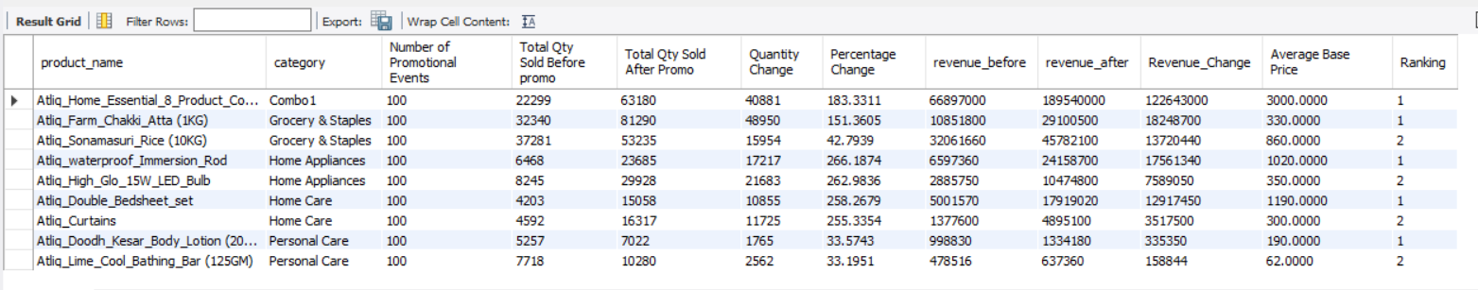

============================================================
CONCEPT COVERAGE
============================================================

SELECT Q1-Q20
WHERE Q1-Q3
DISTINCT Q3
ORDER BY Q2-Q20
COUNT Q4-Q20
SUM Q4-Q20
AVG Q4, Q11, Q16, Q20
MIN / MAX Q4
GROUP BY Q5-Q20
HAVING Q11
INNER JOIN Q7-Q20
Multiple JOINs Q12, Q14, Q17-Q20
Arithmetic Q6, Q13, Q15-Q20
NULLIF Q13, Q16, Q19, Q20
CASE Q16, Q20
CTE Q17-Q20
Window Functions Q17-Q20
PARTITION BY Q17-Q20
RANK/DENSE_RANK Q17-Q20
Business Analysis Q13-Q20

============================================================
RECOMMENDED LEARNING FLOW
============================================================

Q1-Q4:
SQL fundamentals, filtering and aggregation.

Q5-Q10:
GROUP BY, JOINs and basic business analysis.

Q11-Q16:
HAVING, multiple JOINs, calculations, percentages and CASE.

Q17-Q20:
CTEs, window functions, ranking and advanced business analysis.

============================================================
IMPORTANT BUSINESS QUESTIONS LEARNERS SHOULD THINK ABOUT
============================================================

While solving the questions, learners should think about:

1. Which promotion types generate the highest increase in quantity?
2. Which products respond most strongly to promotions?
3. Which categories perform best after promotions?
4. Which cities/stores have the highest promotional volume?
5. Which campaigns generate the strongest product performance?
6. Does a higher quantity increase necessarily mean higher revenue?
7. Which products have the highest revenue improvement after promotion?
8. Which products should be investigated for weak promotional performance?

Do not answer these questions separately. Use SQL queries to derive the answers.

